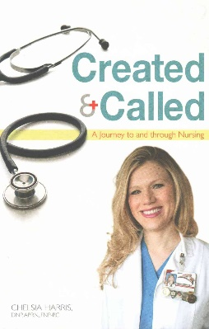
August 2017
AUGUST 6
Created & Called – A Journey to and through Nursing by Chelsia Harris (Youth EDU HAR). Have you ever wondered: “What are my gifts? What exactly is God calling me to do with my life?” Although the profession of nursing can provide a cofortable income, it is more than just a salary. Eternal rewards are reflected when a nurse aids in the alleviation of a patient’s pain, leads a dying patient in a prayer of salvation, or has the opportunity to assist in the welcoming of a new life into this world. I challenge you to keep your heart and mind open to this possiblity for your life. Please read this book, search your heart, cultivate a deeper, more intimate relationship with Jesus Christ, and close the book knowing whether God is calling you to this incredible, humbling profession called nursing. Never forget we can do all things through Christ who strengthens us.

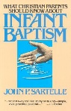
AUGUST 13
What Christian Parents Should Know About - Infant Baptism by John P. Sartelle (234.1612 SAR). The children of believers are special in God’s sight. John P. Sartell shows why they are special and what it means for them to be baptized. Parents whose children have been or are about to be baptized will find Sartelle’s concise booklet to be just what they need to better understand infant baptism. The practical responsibilities of Christian parents and the promises of God regarding their children are set forth clearly in a positive, unargumentative way. Written not for the professional theologian but for ordinary believers, this booklet can be read and enjoyed by all Christian parents.
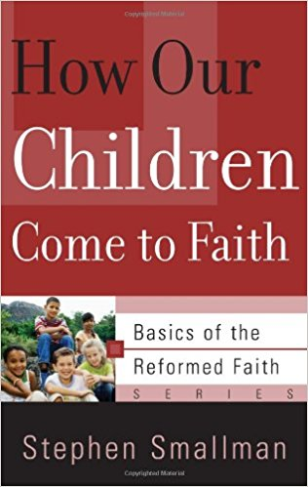
AUGUST 20
How Our Children Come to Faith - Basics of the Reformed Faith by Stephan Smallman (248.845 SMA BRF-08). This helpful, practical booklet encouraged Christian parents to raise their children in a spirit of faith rather than anxiety, emphasizing the importance of bringing children to Jesus for His blessing. The author goes on to explain the meaning of regeneration and conversion as they relate to children raised in Christian Families.

AUGUST 27
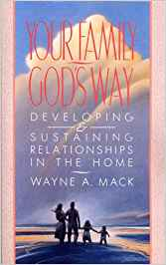
Your Family God’s Way - Developing & Sustaining Relationships in the Home by Wayne A. Mack (248.845 MAC). Why do some families grow closed, when others fall apart? A husband, father of four and family counsellor, Wayne A. Mack offers biblical insight and practical wisdom into two crucial areas of family relationships: communication and conflict resolution. Alerting us to pitfalls such as “undertalk,” “overtalk,” poor listening, falsehood, and “circuit jammers” to communication, Mack examines why families fight and explains the key to turning family discord into concord. Firsthand success stories and highly practical application questions give hope and clear direction to all who wish to build their families – God’s way.

