October 4 2020
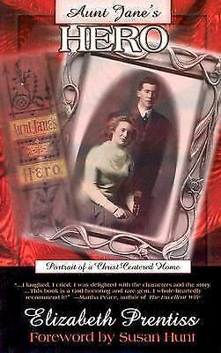
Aunt Jane’s Hero by Elizabeth Prentiss (NOVEL PRE). Aunt Jane’s hero, Horace Wheeler, was handsome, quick-witted and poor. Horace’s one desire was to be in love, which led him even into proposing! Aunt Jane was a sincere, kind-hearted Christian widow that was not always appreciated for her words of wisdom or her little “sermons”. Those little sermons interfered with the good times he had with the less serious youth he kept company with. Horace’s unfailing sense of humor and easy manner made him a favourite in his crowd. Aunt Jane’s prayers continually followed Horace after enlisting in the Civil War where he became a different person; not only physically but spiritually. Aunt Jane’s Hero is a well told Christian story of how God can work in the life of young people.

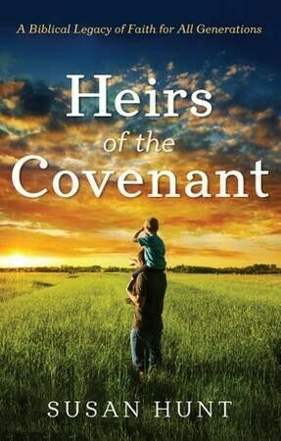
October 11
Heirs of the Covenant – Leaving a Legacy of Faith for the Next Generation by Susan Hunt (268 HUN). True education offers far more than secular education methods sprinkled with Bible stories. It teaches people of every age to think and live Christianly. And it makes teachers of us all. Whether you’re a parent or grandparent, a Christian school teacher, or a youth leader or pastor, you are responsible to help develop the community of believers into a unified, vibrant fellowship and to draw families together in committed relationships that extend beyond generational lines. This practical plan for integrating Christian education into all of life shows what happens when, day by day, week by week, generation by generation, Christians exercise the privileges and responsibilities of covenant living. Regardless of your role in God’s Kingdom, here is motivation to leave a legacy of faith for the next generation --- and to live for Christ today in your home, church, and community.
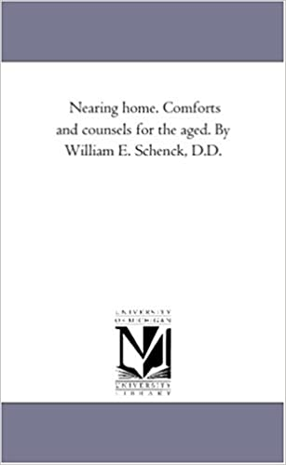
October 18
Nearing Home – Comforts and Counsels for the Aged by William E. Schenck D.D. (248.85 SCH). This choice volume was compiled in 1868 and comprisses a wonderful compendium of writings on the subject of the believer’s home in heaven. Containing hymns, poems, sermons and articles it mines the rich vein of truth in the Word of God onccerning the glory that awaits the believer. What William Schenck states in his preface is equally true today: “In this day, when so much labour is expended into producing almost innumberable books for the young, there is a danger of our neglecting the aged ones who are about to pass off this stage of life.” Whether we be old or young, thoughts of heaven are not only comforting but most necessary if we are to maintain our usefulness and remain faithful to our Saviour. Too infrequently is heaven the theme of our sermons and the subject of our praise. Among the pieces chosen are a number that challenge us as to our state and preparedness for heaven. Those engaged in visiting the elerly will find this a most helpful source of counsel and comfort, whilst all may benefit from its contents.
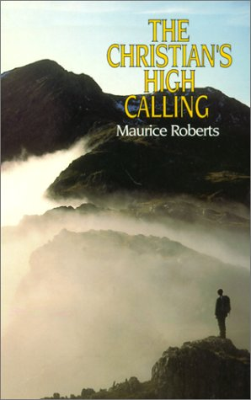
October 25
The Christian’s High Calling by Maurice Roberts (248.48 ROB). A reviewer described Maurice Roberts’ earlier book The Though of God as ‘a contemporary work with the depth of the classics which speaks across denominational and cultural lines’. His new book has the same classic quality and universal Christian appeal. The theme is the Christian life as a high and glorious calling, with present enjoyment, duties and conflicts, leading ot ht eunutterable glory and holiness of the world to come. Readers will glimpse afresh the beauty and majest of God and the priceless privilege of being called to an unending fellowship with him.

