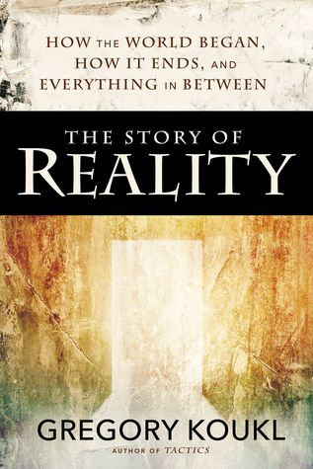
October 6 2019
The Story of Reality – How the World Began, How it Ends, and Everything Important That Happens in Between by Gregory Koukl (239 KOU). In this book the bestselling author Gregory Koukl unpacks the story of our world through a wide-angle lens, introducing you to some of the most important question every person must ask about life, death, the evil in this world, and why we are here. This is the story of the Bible told through five simple and easy-to-remember words: GOD, MAN, JESUS, CROSS, and RESURRECTION. These five words capture the meaning of our humanity and of all human history from beginning to end. For those of you still seeking answers to the questions of life, this is an invitation to hear a story that explains the world in a way nothing else will. This story can change your life forever.
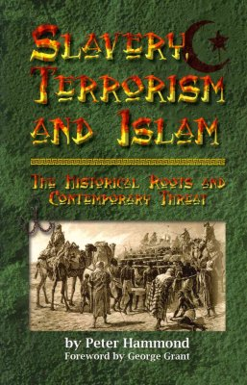
October 13
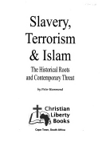Slavery, Terrorism and Islam – The Historical Roots and Contemporary Threat by Peter Hammond (297.1 HAM). This is a fascinating well illustrated and thoroughly documented response to the relentless anti-Christian propaganda that has been generated by Muslim and Marxist groups and by Hollywood film makers. As Karl Marx declared: “The first battlefield is the re-writing of History!” This book is a must read for all those who want to find out the roots of the Terrorism that is threatening global security.

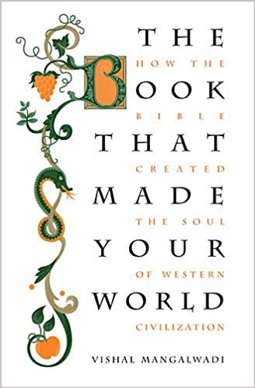
October 20
The Book That Made Your World – How the Bible Created the Soul of Western Civilization by Vishal Mangalwadi (220.09 MAN). Journey with Mangalwadi as he examines the origins of a civilizations greatness and the misguided beliefs that threaten to unravel its progress. Learn how the Bible transformed the social, political, and religious institutions that have sustained Western culture for the past millennium, and discover how secular corruption endangers the stability and longevity of Western civilization.

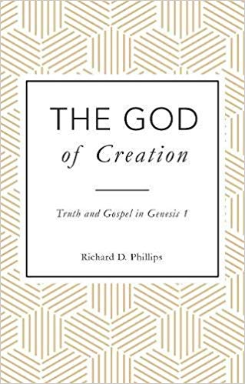
October 27
The God of Creation – Truth and Gospel in Genesis 1 by Richard D. Phillips (231.765 PHI). The opening chapters of Genesis are a battleground: treated with contempt by the secular world they also divide Christians as believers struggle with the question of whether we should take the text literally, or adopt a view that tries to reconcile the words of Scripture with the dominant scientific theories of our culture. Not surprisingly many chose to avoid the issues and keep quiet! Richard Phillips takes a fresh look at Genesis 1 and shows that the doctrine of Creation is central to Scripture as a whole and vital to our understanding of the gospel.

