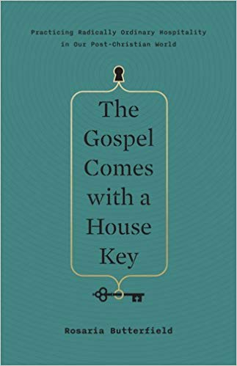
September 8 2019
The Gospel Comes with a House Key – Practicing Radically Ordinary Hospitality in our Post-Christian World by Rosaria Butterfield (241.671 BUT). This book will stir your imagination to generate creative ways to incorporate radically ordinary hospitality into you own life. This book is the aurthor’s heart reaching out to our hearts, calling us to love our neighbours with sacrificial hospitality. Butterfield makes a bold case for putting hospitality back into the essential rhythm of the church’s daily life. This book isn’t for those who want to live the comfortable Christian life. Rosaria proves there is no such thing.

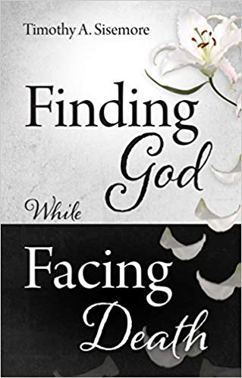
September 15
Finding God While Facing Death by Timothy A. Sisemore (236.2 SIS). Scripture does not ignore or diminish the heartbreak involved in dealing with death, and facing death should not be avoided or feared by the Christian. Looking at this last enemy puts life and our faith into perspective – an eternal perspective. Whether you are facing death yourself, or coming to terms with the impending or recent death of a loved one, you will find food for your soul in these pages.
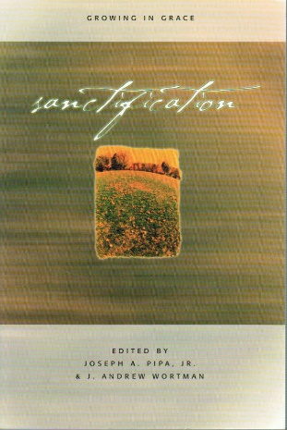
September 22
Sanctification – Growing in Grace by Joseph A. Pipa, Jr. & J. Andrew Wortman (241 PIP). The purpose of this book is to look again at the doctrine of sanctification in its biblical fullness. The majority of the book is dedicated to a positive development of the doctrine by discussing definitive sanctification, progressive sanctification, mortification of the flesh, adoption and the means of grace.

September 29
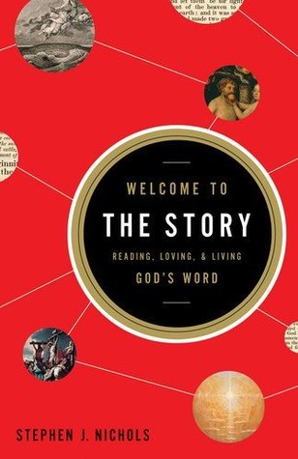
Welcome to the Story Reading, Loving, & Living God’s Word by Stephen Nichols (220.6 NIC). We may be diligent readers of the Bible and sincere in our desire to relate to its stories, but somewhere between our resolve and reality, we find a disconnect. Could it be that we often miss the forest for the trees? Could it be that we inadvertently try to make the narrative, the story, about us? In one sense, the story is about us. It is about our creation, our fall into sin, our redemption, and our restoration. We are indeed part of the story, and God has given us each a role. But, more than that, the Bible is a fascinating story about God – His work, His character, His plan, and His fame. It’s evocative, compelling, meaningful, and of greatest importence. It’s full of flawed characters, grand schemes of redemption, heartache, compassion, toil, and love. And we – all of us – are invited to take up and read the very Word of God. Here is a book that invites you to enter, to participate, and to truly appreciate the very story of God.

