April 2018
APRIL 1
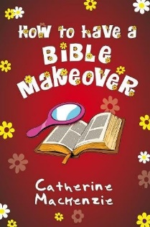
How to have a Bible Makover by Catherine Mackenzie (YOUTH MAC) – If you had a makeover, somene would style your hair, change yoru clothes and give you jewellery. You’d be sorted! Ready for anthing! Well, not quite. Because that kind of makeover doesn’t last. What about a Bible makeover? Well, that’s different. For a start, it’s about who you are – not just about how you look. Someone who has a Bible makeover is given a new heart, a new mind, a new identity. It’s about become part of God’s family. The Bible makover doesn’t fizzle out in a day or two. It is something God works on with you all your life, making you more like Jesus, God’s Son. And this makeover will last for eternity. Open up your Bile, come alongside God, and relaaax. It’s time for our makover.
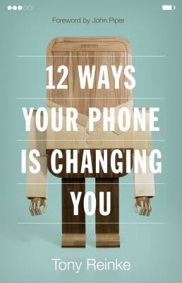
APRIL 8
12 Ways Your Phone is Changing You by Tony Reinke (EDU 261.56 REI) -- Do you control your phone or does your phone control you? Within a few years of its unveiling, the smartphone had become part of us, fully integrated into the daily patterns of our lives. Never offline, always within reach, we now wield in our hands a magic wand of technological power we have only begun to grasp. But it raises new enigmas, too. Never more connected, we seem to be growing more distant. Never more efficient, we have never been more distracted. Drawing form the insights of numerous thinkers, published studies, and his own research, writer Tony Reinke identifies twelve potent ways our smart phone have changed us – for good and bad. Reinke calls us to cultivate wise thinking and healthy habits in the digital age, encouraging us to maximize the many blessings, avoid the various pitfalls, and wisely wield the most poerful gadget of human connection ever unleased.
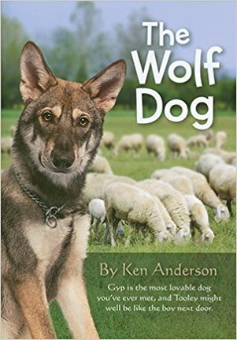
APRIL 15
The Wolf Dog by Ken Anderson (YOUTH AND) -- Gyp is the most lovable dog you’ve ever met, and Tooley might well be like the boy next door. Tooley Paggert had faith in his dog Gyp even though Gyp looked just like a wolf – because he was part wolf, you see. Tooley’s faith was unshaken even in the face of seeming evidence that Gyp was turning into a sheep-killer. Mrs. Paggert, Tooley’s mother , was almost ready to turn the dog over to the police, when Gyp proved, beyond the shadow of a doubt, that he was not harming the sheep. Boys, and girls too, will thrill to this stirring story of a boy’s faith in his dog – and his faith and confidence in God. Tooley prayed about his problems – but he did something about them, too.
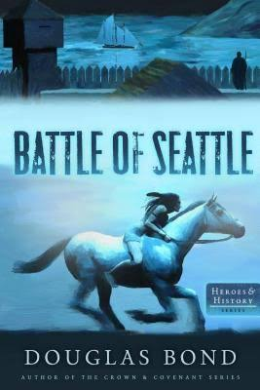
APRIL 22
The Battle of Seattle by Douglas Bond (HIS BON) -- It’s 1855 in the Pacific Northwest, and hostility between whitesettlers and native tribes is rising quickly, leading to deaths on both sides. As tensions mount, young William Tidd joins Charles Eaton’s Rangers on a mission to hunt down Chief Leschi of the Nisqually. If they can stop him, they may be able to end the bloodshed before it gets worse . . . but not everyone wants peace with the enemy. Is all-out war inevitable? Through shirmishes, raids, close calls, and betrayal – William’s assumptions, beliefs, courage, and friendship will all be challenged in a few breakneck weeks.

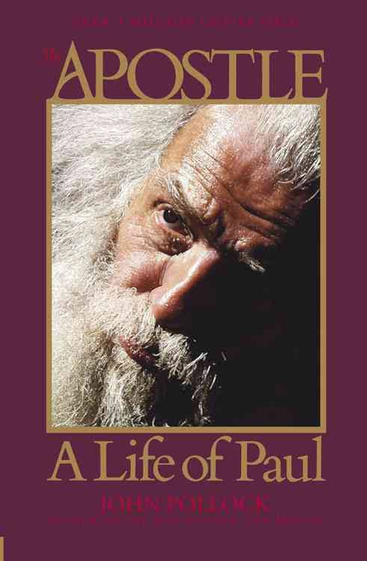
APRIL 29
The Apostle – A life of Paul by John Pollock (BIO POL) – Paul’s Story – meticuloulsy researched, masterfully revealed. A respected leader, a murderer a convict, and a revolutionary, the apostle Paul helped transform the world. Yet few know what his life was really like. Premier biographer Johhn Pollock masterfully weaves Paul’s dramatic, real-life tale into a novel-like read while maintaining the scrupulous scholarship he is known for. He meticulously blends research with captivating storytelling to show the whole picture of the famed apostle.

