January 6 2019
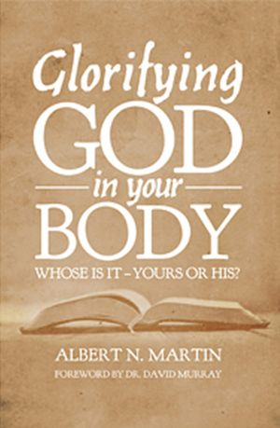
Glorifying God in your Body – Whose Is It – Yours or His? by Albert N. Martin (248.4 MAR). “It seems that our culture promotes either one extreme or the other – either that we worship our bodies or completely neglect them. The governemnt tells us that obesity in our country is at an epidemic level. There is no shortage of “Christian” programs, support groups, and exercise videos aimed at weight loss. However, there is a genuine dearth of pointed practical exhortation based on sound biblical and theological instruction to help God’s people avoid sinful extremes and glorify Him with their bodies. Glorifying God in Your Body helps to fill this void. A. N. Martin is thoroughly scriptural, practical, and evangelical – pointing to Christ as our one geat motive and our only hope for strength to follow the Bible’s teaching that we should discipline our bodies for His glory. – Pastor David Chanski.

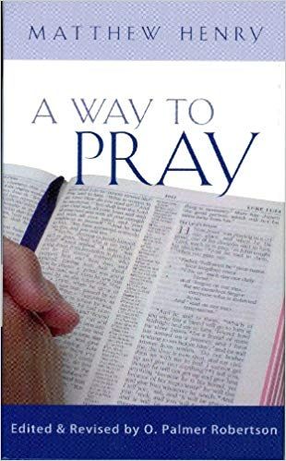
January 13
A Way to Pray by Matthew Henry (248.32 HEN). Prayer in this form is nothing more and nothing less than what the old Puritans called ‘pleading the promises’. God has made promises to His people. His people respond by redirecting those promises to the Lord in the form of prayer. How could a God who is faithful to His word fail to answer prayers of this kind? He has promised. He will honour that promise. If Christians would join together and form their prayers with the maturity and insight provided by Scripture itself, the impact on the world could not be measured.

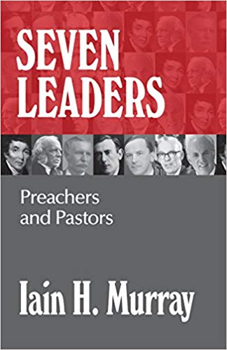
January 20
Seven Leaders – Preachers and Pastors by Ian H. Murray (BIO MUR). John Elias, Andrew Bonar, Archibald Brown, Kenneth Macrae, Martyn Lloyd-Jones, W. J. Grier, John MacArthur. ‘Remember your leaders, those who spoke to you the word of God. Consider the outcome of their way of life and imitate their faith.’ Hebrews 13:7 ESV.

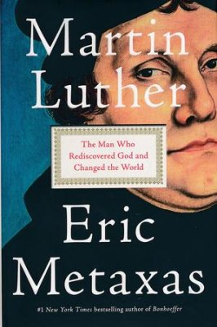
January 27
Martin Luther – The Man Who Rediscovered God and Changed the World by Eric Metaxas (BIO MET). “When Martin Luther made it possible to read the Bible for yourself, he did more than anyone else to create the future. Read this book for yourself to understand the story we’re all still lviing through.” Peter Thiel

