April 2017
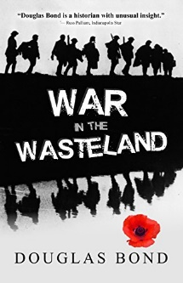
APRIL 2
War in the Wasteland by Douglas Bond (Novel BON). “Douglas Bond is a historian with unusual insight.” This story is a gripping, informative, adrenalin-producing picture of World War 1. “Full-scale assault,” said Sergeant Ayres. “Another one?” said Nigel. “Boche learned nothing from the last one?” “Not them.” Ayres shook his head soberly. “It’s a counter attack. Tomorrow morning, first light. It’s us over the top.”
APRIL 9
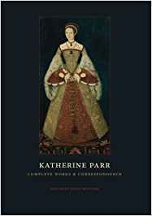
Katherine Parr - Guided Tour of the Life and Thought of a Reformation Queen by Brandon G. Withrow (BIO WIT). This book examines the life of an important, but often forgotten, Protestant Reformer. Katherine Parr, one of only a handful of women to publish in a hundred-year period in England, dared to push Henry VIII toward the Reformation, nearly losing her head as a result. This volume is a guided tour of her life, her contributions to the Reformation, and her writings. Including the full text of her two books as well as select letters. Katherine Par presents both an intimate portrait of a woman struggling to make a difference, and a reintroduction of a classic text to the contemporary church.
APRIL 16
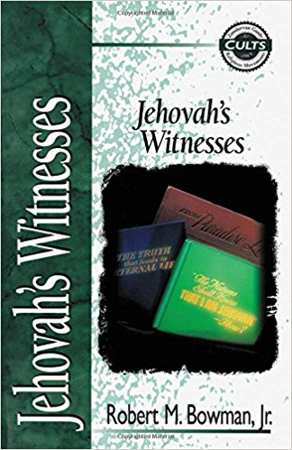
Jehovah’s Witnesses by Robert M. Bowman, Jr. (Edu 299.7 BOW). The zeal and dedication of Jehovah’s Witnesses mask a highly disciplined organization that has a troubled history. Moreover, their thorough knowledge of their own scriptures give a pretense of having spiritual truth. The movement has grown from about 1.1 million worldwide in 1965 to 4.4 million today. Yet all is not what is seems in the Watchtower Society. How do the teachings of the Jehovah’s Witnesses run counter to orthodox Christianity? What drives adherents to give hundreds of hours a year to “Witnessing”? What draws converts to a cult of strict control by religious leaders?

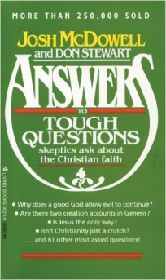
APRIL 23
Answers to Tough Questions Skeptics Ask About the Christian Faith by Josh McDowell and Don Stewart (Theology 239 MCD). Why does a good God allow evil to continue? Are there two creation accounts in Genesis? Is Jesus the only way? Isn’t Christianity Just a crutch? … and 61 other most asked questions!

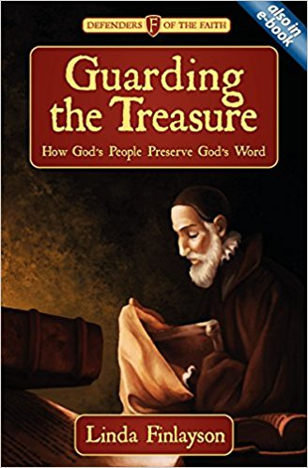
APRIL 30
Guarding the Treasure – How God’s People Preserve God’s Word by Linda Finlayson (Youth BIO FIN DOF-1). When a powerful king learned to read, his people came to understand the true value of God’s Word. When a young scholar translated the Bible into English he risked his life to smuggle it into the country. When a young man turned down the challenge to fight for his country it meant there was one less soldier for America but one more to make sure that the people of Guatemala received Bibles. Then in 1982 a young woman peers intently towards the sky … an aeroplane is due with some precious cargo. This plane has boxes and to find out their contents go to chapter one!

