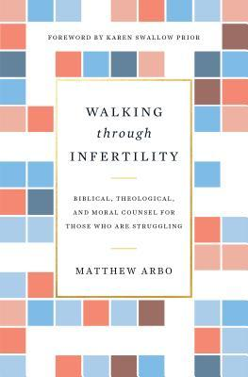
December 1 2019
Walking Through Infertility – Biblical, Theological, and Moral Counsel for Those Who Are Struggling by Matthew Arbo (241.6 ARB). “This book was written to help you see and understand that God is the Giver of life. You are His child. He cares deeply about you. When you hurt, He hurts with you.” Infertility is the profoundly wounding experience of many couples, often leading to feelings of despair and shame as they grapple with shattered dreams and unanswered questions. But God does not leave them alone in their pain. The Creator and Redeemer of life has not forsaken the infertile, but has called and equipped them to participate in His church, kingdom, and mission. Overflowing with warmth and sensitivity, this book explores what the Bible says about infertility, helping the church walk alongside couples struggling with infertility and assessing the ethical issues surrounding common fertility treatments and reporductive technologies.

December 8
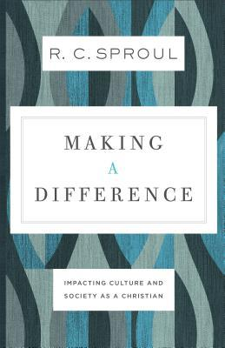
Making a Difference – Impacting Culture and Society as a Christian by R. C. Sproul (241.6 SPR). The world needs your faithful influence. We live in a complex world, and confrontations between competing worldviews and value systems are common. The great challenge for the Christian is how to impact this fallen world with our faith. To have the greatest influence on someoneone who doesn’t share our belief system, we have to start with knowing what they believe, why they believe it, and how that belief affects their attitudes, behaviours, and choices. In Making a Difference, beloved theologian R. C. Sproul shows you how to confront today’s moral and social issues with an effective biblical response. Dr. Sproul first examines the major philosophies that affect the way we think and act – secularism, existentialism, humanism, and pragmatism – and then presents ideas on how to apply a biblical perspective to spheres of public life that need your faithful influence today: economics, science, art and literature, and government. If you long to make a real and lasting difference in your family, friend group, workplace, and community, this book will show you how.

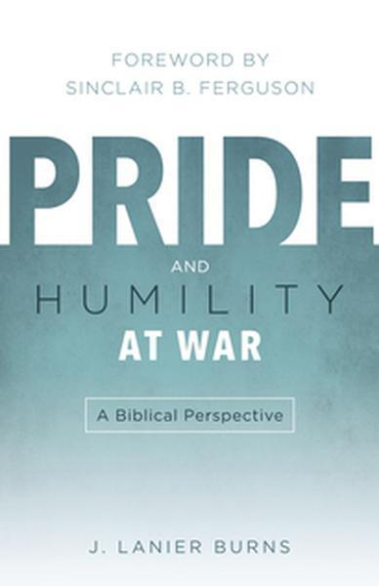
December 15
Pride and Humility at War – A Biblical Perspective by J. Lanier Burns (241.4 BUR). Is pride a necessary tool to achieve significance? Is humility a form of self-hatred? In contrast to the world, the Bible consistently presents humility as the supreme virtue, while pride is the underlying depravity behind specific sins. Pride and humility are at war . . . and humility, not pride, has the advantage. Humility’s surprising essence is God-centeredness – living for the glory of God rather than self. On the basis of this biblical principal, Christ’s example, and the comtemporary need, J. Lanier Burns argues for an unfamiliar connection between true significance and a humble dependence on the Lord.

December 22
She’s Got the Wrong Guy – Why Smart Women Settle by Deepak Reju (241 REJ). A different kind of dating book, This book not only details why these are the wrong guys, but also helps single Christian women better understand why they “settle” for less than God intends. Instead, they will be encouraged to put their hope and happiness in Jesus, not marriage. “Tired of waiting for the right man to come along? Weary of delaying ‘wedded bliss?’ Are you tempted to redefine love so you can accommodate a lesser man in an okay marriage?” If you’re looking for the emotional strength to wait well on God’s man, Deepak Reju has written the perfect guide in this remarkable book.

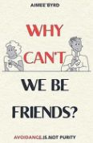
December 29
Why Can’t We Be Friends? – Avoidance is Not Purity by Aimee Byrd (261.8 BYR). The Church stands firm against culture on many issues of sexuality . . . but misses this one! Society says we are merely sexual beings and should embrace this, and in the church we use this same view as an excuse to distrust and avoid each other! We shy away from healthy friendship, and even our siblingship in Christ, in the name of purity and reputation . . . but is this what we are called to do? Aimee Byrd reminds us that the way to stand against culture is not by allowing it to drive us apart – it is by seeking the brother-and-sister closeness we are privileged to have as Christians. Here is a plan for true, godly friendship between the sexes that embraces the family we truly are in Christ and serves as the exact witness the watching world needs.

