May 5 2019
The Woman Who Loved to Give Books by Susannah Spurgeon (P VAN) What does Mrs. Spureon do when her house is full of books? She gets a nw hours, but she also geta a great idea… Find lions on a shelf, a bird in a cage, and opal ring as you read the story of Susannah Spurgeon’s service for the Lord.

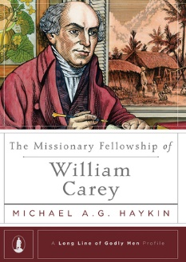

May 12
The Missionary Fellowship of William Carey by Michael A. G. Haykin (BIO HAY). The Long Line of Godly Men Profiles, conceived by Series Editor Steven J. Lawson, are designed to introduce giants of the Christian faith and to show how they used their particular spiritual gifts, personality traits, or ministry abilities in serving God. The goal of the series is to set forth followers of Christ who are themselves worthy to be followed. In the Missionary Fellowship of William Carey, Dr. Haykin examines Carey’s life and work, gleaning lessons for our time about the indispensability of friends and fellow workers in ministry as the church seeks to carry out the Great Commission.

May 19
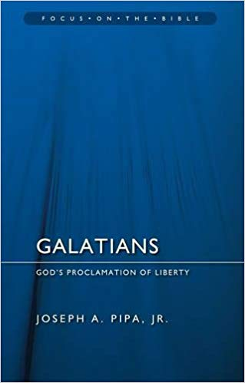
Galatians – God’s Proclamation of Liberty by Joseph A. Pipa, Jr. (227.4 PIP).The glorious doctrine of justification by faith far exceeds even the great charters of freedom and liberty which we have seen throughout history. This doctrine is expounded by the apostle Paul whose letter this is and in it we see the key themes of his theology expounded. Pipa, an able Biblical expositor, brings this important letter with practical lessons for the church of every age alive for us. “Martin Luther once callled the Epistle to the Galatians ‘my Katie von Bora’ – this letter was as dear to the Reformer as his own wife. In the commentary on Galatians, Pipa has given the church a clear, stirring, and accessible exposition of this beloved letter.”

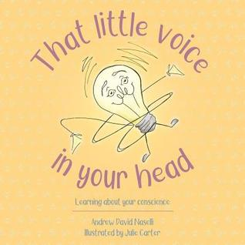
May 26
That Little Voice in Your Head - Learning About Your Conscience by Andrew David Naselli (J NAS). If kids could be five years old again, I would definitely read this book to them. One of the best things about a biblically rooted children’s book is that it helps parents as much as kids. I have no doubt that will happen with this book. And while you’re at it, tell your teenagers they can sit all the way across the room but they do have to listen the first time through.

