May 2018
MAY 6
Betty Greene – Courage Has Wings by Irene Howat (YOUTH HOW) – Planes are frequent sights in our skies today. In the early years of the twentieth century they were new, exciting … dangerous even. Betty Greene was one of the early women to learn to fly these amazing new machines. That took courage, especially during World War II when soldeirs practiced their marksmanship by shooting at a target attached to her plane. After the war, Betty helped to set up an organisation that used aircraft to support mission work and she was its first pilot. Later, that organisation became Mission Aviation Fellowship. In Latin America, African and Irian Jaya, Betty Greene flew her aircraft with courage and skill, all the while trusting God to keep her and her passengers safe.
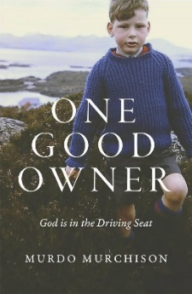
May 13
One Good Owner - God is in the Driving Seatby by Murdo Murchison (BIO MUR) – Murdo Murchison’s life turned upside down on the 30th of August 2016 when he collapsed with a massive seizure. Within sx hours he was holding the result of a CT scan showing a two centimetre turmour in his brain. This book brings together experiences from Murdo’s life which are made all the more powerful and poignant with the centrainty that time is short. From the humourous exploits of his Highland childhood to heartfelt stories about his family and friends, each chapter flows with a love for his Lord and Saviour.
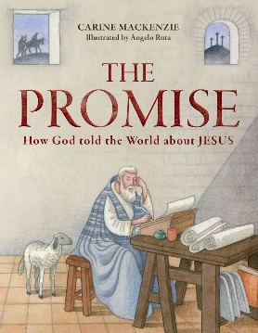
MAY 20
The Promise - How God Told the World about Jesus by Carine Mackenzie (J MAC) – At the beginning of time, a promise was made by God. He promised to save His people from their sin by sendig His Son, the Saviour. One after the other, people heard the message and told the world about God’s plan to send a Saviour, God’s Son, the Lord Jesus Christ. The promise that was made in the Garden of Eden came true in the Garden tomb, when the Saviour who was sacrificed, crushed death and came back to life. All through history, God had told the world that this wourld happen – and it did! The promise was kept.
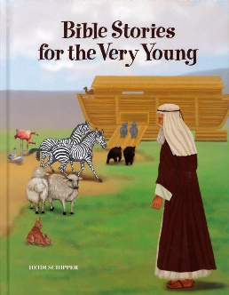
May 27
Bible Stories for the Very Young by Heidi Schipper (P SCH) – The selecion of Bible stories, retold in simple language, will introduce toddlers and young children to five stories found in the book of Gensis. The vivid illustrations will appeal to children of all ages. Each story is followed by simple questions to help children understand and apply biblical truths. God Made Everything; Adam and Eve; Noah and the Flood; Joseph and the Colourful Coat; Joseph in Egypt.

