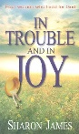
March 3 2019
In Trouble and in Joy – Four women who lived for God by Sharon James (BIO JAM). Many of today’s women struggle for position and recognition in a highly competitive society, but In trouble and in joy illustrates beyojnd doubt from the lives of four Christian women of the past that the secret of lasting influence lies in godliness.
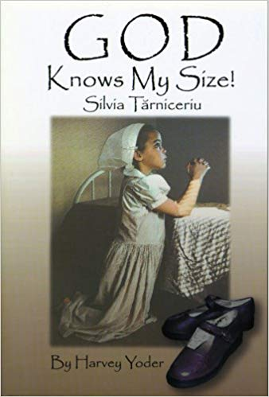
March 10
God Knows My Size – Silvia Tarniceriu by Harvey Yoder (BIO TAR). Is there really a God? This is the question 13-year-old Silvia faced. Her teachers laughed at the mere idea of God. Yet her parents and pastor not only believed in God, but served Him devotedly. Which of them was right? So Silvia decided to find out for herself if God was real. She asked Him for three things – a pair of shoes, a sweater and a coat. For a large, poor, Christian family in communist Romania, these things were almost impossible to buy. How could she expect a miracle? But it happened! God answered her prayer in a way far more beautiful than she expected! And the truth He showed her then sustained her years later as she faced persecution and even prison for Christ’s sake. Read this book and find your faith in God strengthened.
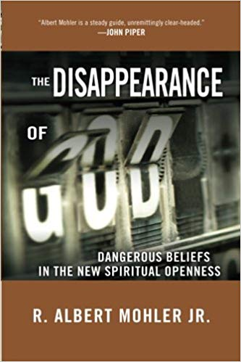
March 17
The Disappearance of Dangerous Beliefs in the New Spiritual Openness by R. Albert Mohler Jr. (273 MOH). Do you really know what spiritual lies you’re swallowing? More faulty information about God swirls around us today than ever before. No wonder so many followers of Christ are unsure of what they believe in the face of the new spiritual openness attemptiong to alter unchanging truth. We need to know the truth to save ourselves from errors that will derail our faith. As biblical scholar, author, and president of The Southern Baptist Theological Seminary, Dr. Albert Mohler writes, “The entire structure of Christian truth is now under attack.” With wit and wisdom he tackles the most important aspects of these modern issues: Is God changing His mind about sin? In the age-old battle to preserve the foundations of faith, it’s up to a new generation to confront and disarm the contemporary shams and fight for the truth. Dr. Mohler provides the scriptural answers to show you how.
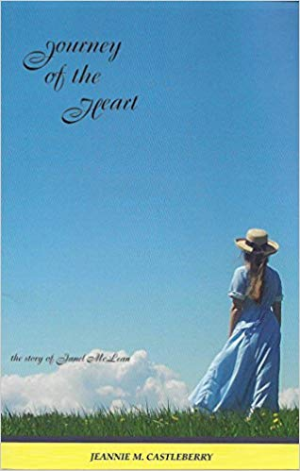
March 24
Journey of the Heart – The story of Janel McLean by Jeannie M. Castleberry (NOVEL CAS). Journey of the Heart is the long-awaited story of Janet McLean. Janet, now twenty-two years old, has matured and grown in the Lord. She has many longings, struggles, and questions that she must face with the help of the Lord and her parents. Will anyone ever want to court her? How should she handle her desires for a husband and family of her own? When she finds herself attracted to a young man, what should she do? This is the very honest account of a young woman who is still waiting on the Lord. Journey of the Heart is part of the Courtship Series, which encourages active parental involvement as young adults seek a mate. The main characters in the book are committed followers of Jesus Christ, and Christian family values are emphasized throughout. The reader will be encouraged to heed parental advice and to live in obedience to the Lord.

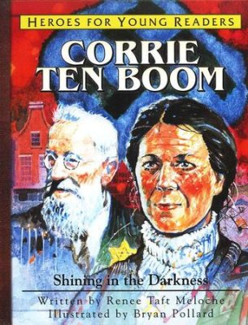
March 31
Corrie Ten Boom – Shining in the Darkness by Renee Taft Meloche (YOUTH BIO TAF HFYR-07). Introduce children to the exciting true stories of Christian heroes. When Nazi Germany occupied Holland, Corrie ten Boom risked everything to extend God’s hand of love and protection to her Jewish neighbours. A perfect hiding place was built into the wall of Corrie’s bedroom, but would Corrie have the courage to keep the secret, even if it meant she and her family would suffer greatly? In the darkest of nights, Corrie’s compassion, sacrifice, and forgiving spirit were a shining testimony to the triumph of God’s love over evil. Now Heroes for Young Readers makes Corrie ten Boom’s remarkable story available in this picture book all ages will treasure.

