March 2018
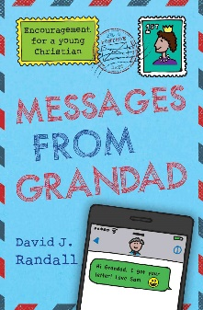
MARCH 4
Messages from Grandad by David J. Randall (Youth NON FIC RAN) – What about making it a resolution to write each other every few weeks…? And so it begins – an amazing year’s worth of correspondence between a grandfather and his grandchild, Sam. Issues and questions tht every young Christian has to tackle are dealt with in a warm but direct way. Between the two of them many topics are discussed and chewed over, such as “How can you believe in God hwen so many horrible and wicked things happen in the world?”, “Science has disproved the Bible.”, “The Bible is full of contradictions.”, “If you need a crutch, go ahead, but we can manage fine without religion.”, “Christianity is just wishful thinking.”, “What really matters is achieving as much money, success or fame as possible.”
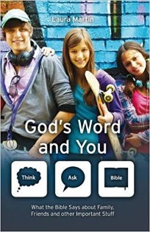
MARCH 11
God’s Word and You by Laura Martin (Youth Non FIC MAR) – What the Bible says about family, friends and other important stuff. You’ve got a mind – use it! If you’ve got questions – ask them! But don’t fill your mind with rubbish and it is important to ask the right questions. So how do you make sure that your’re headed in the right direction? Well – THINK, ASK – BIBLE! God’s Word is the crucial ingredient. Read it – study it – learn it – think about it. God’s Word will help you with your questions about famiy, friends, and other important stuff like work and worry, troubles and trials and even your body. Find out about how David, Jonathan, Joseph, Martha, and others experienced the same issues as you do every day of your life – and how God is the same all powerful God for you as He was for them.
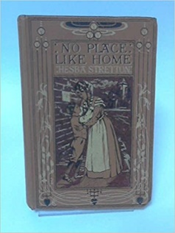
MARCH 18
No Place Like Home by Hesba Stretton (Youth FIC STR) – A story of perserverance and forgiveness, No Place Like Home allows a glimpse into the lives of one of the many poverty-stricken families in England during the last century. The mother’s faith in the Lord Jesus, despite poverty nd hardship, is evidenced in the comfort she received and by her son as he experiences and responds to his own deep trial. Hesba Stretton again brings to life many lessons found in the Christian walk and powerfully reminds us of the hope found therein.
MARCH 25
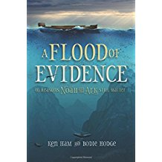
A Flood of Evidence – 40 Reasons Noah and the Ark Still Matter by Ken Ham and Bodie Hodge (231.765 HAM) – Addresses the countless questions asked about the flood over the years! There are hosts of books and resources on the Flood and Noah’s Ark in the creation movement. However, there is a need for a comprehensive layman’s book dealing with the answers to the most asked quesitons on the Flood and Noah’s Ark from a biblical and scientific perspective, and this book fulfills that need. Answers the top questions. Answers in Genesis received about the Flood and Noah’s Ark. Addresses issues in a way that is easy to read, yet still gives the reader substantial facts and insights. Is the perfect “starter” book for those interested in learning more or for believers wanting to share the truth with non believers. Most people in the pews could use a book like this to give them the basic answers they need about the Flood and Noah’s Ark. After reading it, they will be prepared to go into further techniclal or specific, books from there.

